1. Below attirbutes are ahving only UNKNOWS.

|  |
| --- |
| *# of 3rd Party Resources With Access |
| *# of P&G Users With Access |

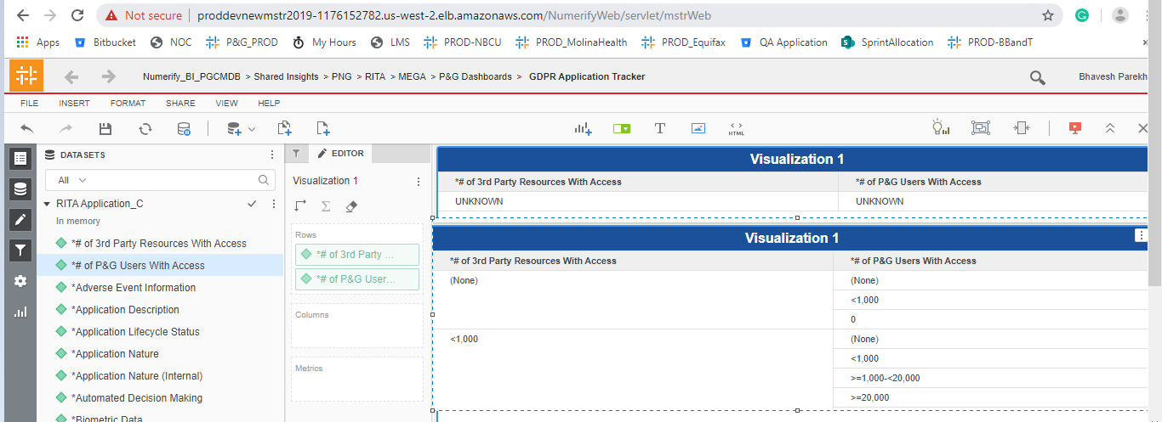

2. *Adverse Medical Event Information is having only N.

3. Different Mega ID ‘s in Dev not available in PROD instance.

